Rendering Fingertip Contact Forces from a Robotic Gripper with a Three-Degree-of-Freedom Pneumatic Tactile Display: Characterization and Perception of Motion Direction
[Author 1], [Author 2], [Author 3], and [Corresponding author], [Member, IEEE]
This work was supported by [funding agency, grant number]. [Author 1] and [Author 2] are with the [Faculty of Mechanical Engineering, Hanoi University of Civil Engineering, Hanoi, Vietnam] (e-mail: […]). [Other affiliations]. Corresponding author: [name, e-mail].
Abstract—In teleoperated grasping, the operator cannot feel how the gripper contacts the object, so the early signs of slip go unnoticed. This paper presents a tactile channel that renders the contact force measured on a two-finger gripper to the operator’s fingertip. Each gripper finger carries an array tactile sensor with 52 three-axis taxels. A host application maps the normal force and the two tangential force components to five pneumatic chambers of a three-degree-of-freedom fingertip display (SuP): one chamber for the normal force and two antagonistic pairs for the two tangential axes. Five electro-pneumatic regulators driven by digital-to-analog converters set the chamber pressures. The display was characterized by the static relation between the sensed force and the chamber pressure and by the frequency response of each chamber. Two psychophysical experiments with [N] participants measured the just-noticeable difference (JND) of each chamber and the accuracy of identifying the direction of object motion. The force–pressure relation was linear with R² ≥ [0.xx], and the −3 dB bandwidth was [x.x]–[x.x] Hz across chambers. The JND was [x.xxx] ± [x.xxx] MPa (Weber fraction [0.xx]). Participants identified the motion direction with [xx]% accuracy (chance level 20%). [One sentence on what the result means for slip warning in teleoperation.]
Index Terms—Tactile sensing, pneumatic tactile display, haptic feedback, teleoperation, robotic grasping.

I. Introduction
When people hold an object, they adjust the grip force to a level just sufficient to keep the object stable rather than squeezing as hard as possible. The grip force follows the mass, surface properties and motion of the object. This regulation relies on tactile afferents in the fingertip, which signal the contact force and the local changes that can appear before the object slips [1]. A robotic gripper needs the same ability to detect the onset of slip early, so that the grip force can be corrected in time and the object is neither dropped nor damaged.
Many tactile sensors have been developed for robots, based on resistive, capacitive, piezoelectric and optical principles [2]. GelSight, for example, uses images of the deforming contact surface to recover the contact geometry and estimate the force [3]. Studies on tactile sensing also indicate that the force distribution over the contact surface supports slip detection better than the total force alone [4]. However, tactile signals depend on the mass, shape, stiffness and friction of the object, so the behavior of tactile features under different grasping conditions must be examined before they can be used for early slip warning.
Tactile information also matters in robot teleoperation, where the operator cannot directly feel the force and contact state between the gripper and the object. Wearable fingertip haptic devices have been developed to convey contact information to the user [5]. Among them, SuP-Ring uses pneumatic chambers and silicone membranes to render the normal and tangential force components through normal indentation [6], and it has been tested in tasks that require perceiving the properties of soft tissue [7]. Tactile feedback of slip has also been shown to help operators detect and respond to object slip [8]. Converting the signals measured on a robot gripper into feedback that the user can interpret, especially the features related to slip, remains an open problem [9].
In previous work, the authors developed a hybrid gripper with passive pneumatic soft joints and a six-axis force sensor at the base to evaluate the interaction force during grasping [10]. That arrangement measures the total force on the mechanism but not the force distribution on the contact surface of each finger, so local changes such as the shift of the center of pressure or of the contact area could not be observed. A first prototype of a three-degree-of-freedom pneumatic fingertip display driven by a single-point force/torque sensor was also built and tested for direction recognition [11]. [One sentence on what the prototype did not quantify, e.g., the force–pressure gain, bandwidth and JND of each chamber.]
This paper connects an array tactile sensor on a two-finger gripper to a five-chamber pneumatic fingertip display and characterizes the resulting tactile channel from the sensor to the operator’s perception. The contributions are as follows.
- A tactile channel that maps the normal force and the two tangential force components measured by an array tactile sensor on a gripper finger to a normal chamber and two antagonistic chamber pairs of a three-degree-of-freedom pneumatic fingertip display.
- A characterization of the display in terms of the static relation between the sensed force and the chamber pressure and the −3 dB bandwidth of each chamber.
- Two psychophysical experiments that measure the JND of each chamber and the accuracy with which a passive wearer identifies the direction of object motion in the gripper.
The rest of the paper is organized as follows. Section II describes the system and the force-to-pressure mapping. Section III presents the fundamental and psychophysical experiments. Section IV reports the results, Section V discusses them together with the limitations, and Section VI concludes the paper.

II. System Description
The system consists of three blocks: the acquisition mechanism, the host computer with the application, and the rendering mechanism (Fig. 1).

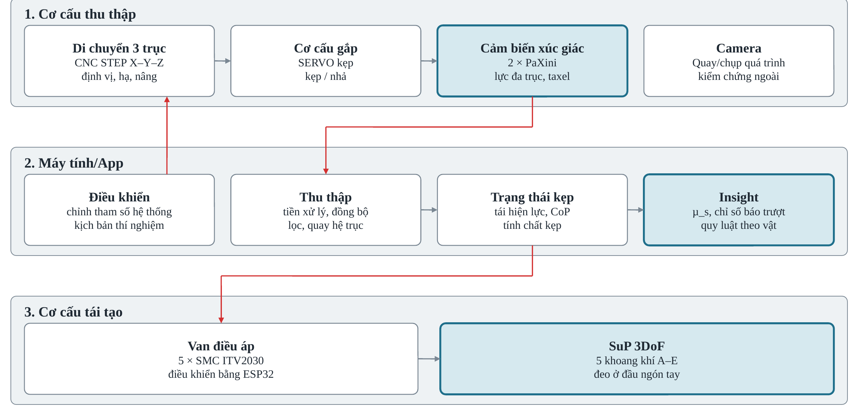
Fig. 1. System block diagram. Red arrows indicate the signal and command paths between the acquisition mechanism, the host application and the rendering mechanism.

A. Tactile Acquisition on the Gripper
A parallel two-finger gripper is mounted on a three-axis CNC stage driven by 17HS8401 stepper motors. The stage moves the gripper to the object, lowers it to the preset grasping height and lifts the object during the experiments. The fingers are opened and closed by a Feetech STS3215 servo with a 12-bit magnetic encoder and feedback of position, load and current. Each finger carries a PaXini S2015-Elite tactile sensor with 52 taxels [12], each measuring the force along three axes. The system can therefore track the force distribution on each finger instead of only the total force. A camera records the grasping process to provide a reference for the sensor signals.

B. Host Application
The control and acquisition software is written in Python and has four functional blocks. The Control block sets the parameters and runs the experimental procedure by sending commands to the CNC stage and the servo. The Acquisition block reads the two tactile sensors and the servo, synchronizes the data in time, filters noise and transforms the measured forces into the common gripper frame. The Grasp state block displays in real time the contact force, the center of pressure (CoP), the contact area and related quantities. The Analysis block aggregates the results of repeated trials. In this work, the application also computes the chamber pressures from the sensed force (Section II-D) and sends them to the rendering mechanism at [xx] Hz over a serial link at [115200] baud.

C. Three-Degree-of-Freedom Pneumatic Tactile Display
The rendering mechanism uses five SMC ITV2030 electro-pneumatic regulators with a set-pressure range of 0.005–0.5 MPa and a 0–5 V command input [13]. An ESP32 microcontroller drives the regulators through two 12-bit digital-to-analog converters (MCP4728 for four channels and MCP4725 for the fifth) and sets the pressure in the five air chambers A–E of the SuP display worn on the fingertip. The operating principle follows SuP-Ring [6]: each chamber is closed by a silicone membrane that indents the skin when pressurized.
Fig. 2 shows the chamber layout. The display has a U-shaped frame that holds the fingertip. Chamber B at the center of the base renders the normal force. Chambers A and C on the base, [distal and proximal] to B, form the pair for the tangential force along the sensor x-axis. Chambers E and D on the two side walls form the pair for the tangential force along the sensor y-axis. [Membrane diameter 5 mm, material and thickness; frame dimensions; tube length and inner diameter.]

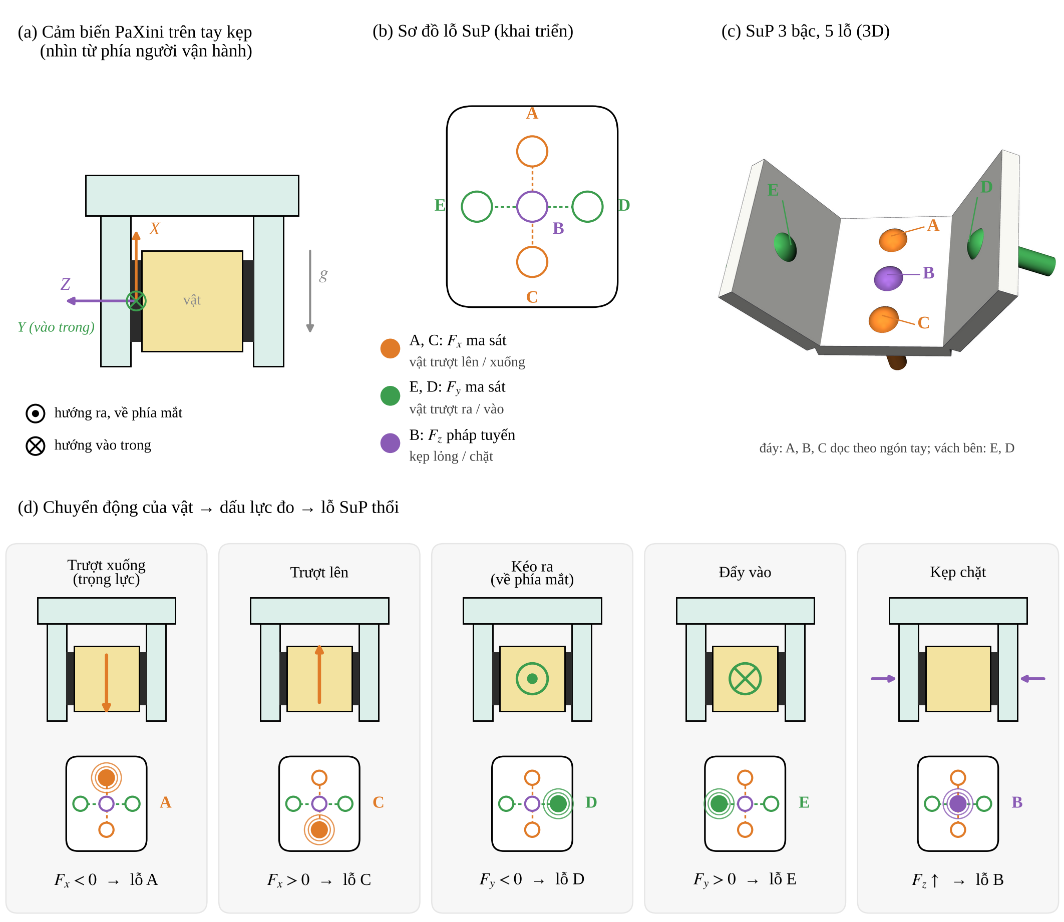
Fig. 2. Mapping from the gripper sensor to the SuP display. (a) Sensor frame on the left finger viewed by the operator. (b) Unfolded layout of chambers A–E. (c) Three-dimensional view of the display. (d) Object motion, sign of the sensed force and the chamber that is pressurized.

D. Force-to-Pressure Mapping
Fig. 3 shows the processing chain from the sensor to the display. The raw taxel forces are tared, low-pass filtered and summed to the resultant force F = (F_{x}, F_{y}, F_{z}) in the sensor frame of Fig. 2(a), where x points upward, z is normal to the sensing surface and y completes the right-handed frame. [Verify the direction of y and z from a static test of the sensor signs.] Each tangential component drives one chamber of its pair according to its sign, and the normal component drives chamber B:
$P_{A}=P_{0}+G_{x} ϕ_{x}\left(-F_{x}\right), P_{C}=P_{0}+G_{x} ϕ_{x}\left(F_{x}\right)$ (1)
$P_{D}=P_{0}+G_{y} ϕ_{y}\left(-F_{y}\right), P_{E}=P_{0}+G_{y} ϕ_{y}\left(F_{y}\right)$ (2)
$P_{B}=P_{0}+G_{z} ϕ_{z}\left(F_{z}\right)$ (3)
where P_{k} is the set pressure of chamber k (MPa), P₀ is the base pressure that keeps the membranes in light contact with the skin, and G_{x}, G_{y}, G_{z} are the gains (MPa/N). The function
$ϕ_{j}\left(u\right)=min\left(max\left(u-f_{dz},0\right),F_{sat,j}-f_{dz}\right)$ (4)
applies a dead zone f_{dz} that suppresses sensor noise and a saturation F_{sat,j} that limits the pressure to P_{max} = P₀ + G_{j}(F_{sat,j} − f_{dz}). With this rule, object motion produces the chamber activation in Fig. 2(d): sliding down gives F_{x} < 0 and pressurizes A, sliding up pressurizes C, pulling the object toward the operator gives F_{y} < 0 and pressurizes D, pushing it away pressurizes E, and squeezing increases F_{z} and pressurizes B. The set pressure is converted to the regulator command through the static calibration of each channel, u_{k} = (P_{k} − b_{k})/a_{k}, where a_{k} and b_{k} are obtained in Experiment 1a. Table I lists the parameters.

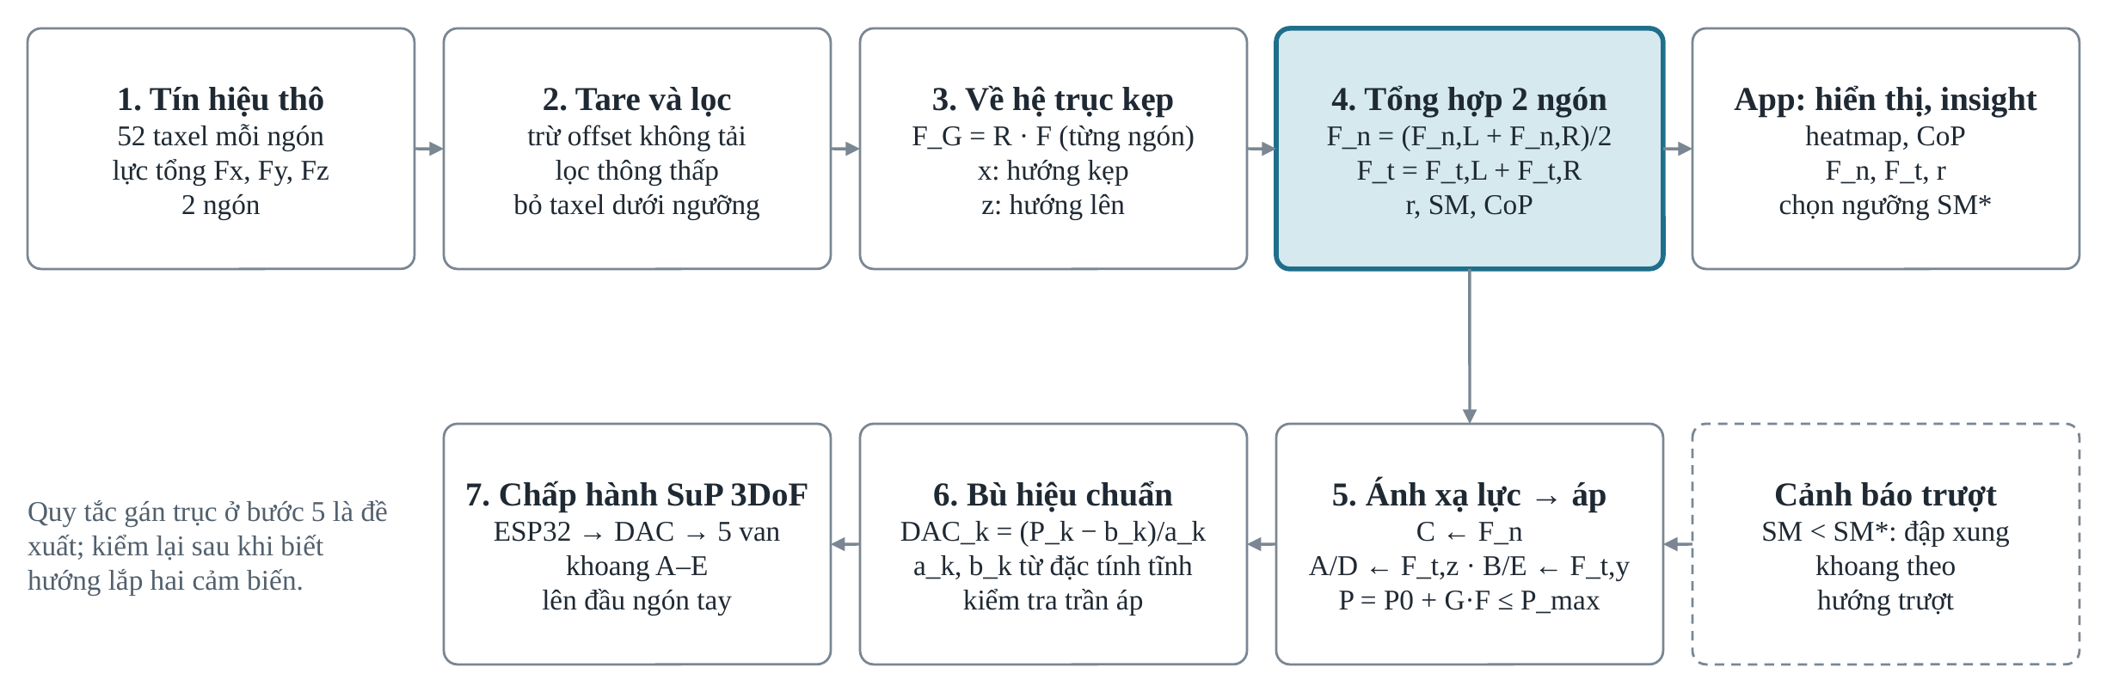
Fig. 3. Processing chain from the tactile sensor to the SuP display.

TABLE I
Parameters of the Force-to-Pressure Mapping
Symbol | Description | Value | Unit
P₀ | Base pressure | […] | MPa
P_{max} | Maximum chamber pressure | […] | MPa
G_{x}, G_{y} | Tangential gains | […] | MPa/N
G_{z} | Normal gain | […] | MPa/N
f_{dz} | Dead zone | [0.2] | N
F_{sat,x}, F_{sat,y} | Tangential saturation | [5] | N
F_{sat,z} | Normal saturation | [9] | N
f_{u} | Update rate of the mapping | […] | Hz

III. Materials and Methods
The experiments were divided into fundamental experiments, which characterize the hardware without a human in the loop (Experiments 1a and 1b), and psychophysical experiments with participants (Experiments 2 and 3). The tactile sensors were calibrated against reference weights before the experiments; the calibration procedure and results are reported in [supplementary material / Appendix].

A. Fundamental Experiments

1) Experiment 1a: Static Force–Pressure Relation
The aim was to determine the relation between the force sensed by the gripper sensor and the pressure delivered to each chamber of the display, which defines the gain of the whole channel. Reference forces were applied to the sensor of the [left] finger through a rigid plate covering the sensing surface. Normal forces were applied with calibrated weights of […] g; tangential forces along ±x and ±y were applied with a force gauge under a constant normal preload of […] N. The force was increased from 0 to [F_{max}] N in […] steps and then decreased to 0. Each level was held for [3] s and the last [1] s was averaged. The pressure of each chamber was measured by [pressure transducer model, range, accuracy] at the chamber inlet [or: by the analog monitor output (1–5 V) of the regulator]. Each loading cycle was repeated [5] times for each of the five chambers. The setup is shown in Fig. 4.
[FIGURE 4 PLACEHOLDER: photograph of the setup for Experiments 1a and 1b with labelled components (gripper, PaXini, regulators, pressure transducer, SuP). One-column width 88.9 mm.]
Fig. 4. Setup of the fundamental experiments.

2) Experiment 1b: Bandwidth
The aim was to measure the frequency range over which each chamber follows the command, which limits how fast a change of contact state can be rendered. To isolate the pneumatic path, the ESP32 generated the command internally, u(t) = u₀ + u_{a} sin(2πft), with u₀ = [50]% and u_{a} = [25]% of full scale, at f = [0.1, 0.2, 0.5, 1, 2, 3, 4, 5, 7, 10] Hz and at least [10] cycles per frequency. The chamber pressure was sampled at [≥ 200] Hz. The tube length and inner diameter were fixed at […] m and […] mm for all chambers. The amplitude A(f) and phase at each frequency were obtained by fitting a sinusoid at the excitation frequency, and the magnitude was expressed as
$M\left(f\right)=20\log_{10}\left(A\left(f\right)/A_{ref}\right)$ (5)
where A_{ref} is the amplitude at [0.1] Hz. The bandwidth f_{c} is the frequency at which M = −3 dB, interpolated between the measured frequencies.

B. Psychophysical Experiments

1) Participants
[N] participants ([n] male, [n] female, aged […] ± […] years, [n] right-handed) took part in Experiments 2 and 3. None reported sensory or motor impairment of the hand. The protocol was approved by [ethics committee, approval number], and all participants gave written informed consent. The display was worn on the index finger of the [right] hand. Participants could not see the gripper or the display, and they wore headphones playing white noise to mask the sound of the regulators and exhaust. The maximum pressure was limited to […] MPa by the supply regulator, and an emergency stop removed the command voltage.

2) Experiment 2: JND of Each Chamber
The aim was to measure the smallest pressure change that a wearer can detect in each chamber. A two-interval forced-choice task was used [14]. Each trial consisted of two 1 s intervals separated by a 1 s pause. One interval contained the reference pressure P_{ref} and the other P_{ref} + ΔP, in random order, and the participant reported the interval with the stronger stimulus. ΔP followed a 1-up-2-down staircase, which converges to 70.7% correct responses [15]. The staircase stopped after [12] reversals, and the JND was the mean of the last [8] reversals. Chamber B was tested at [three] reference levels ([25, 50, 75]% of P_{max}) and chambers A, C, D and E at [50]% of P_{max}. The [seven] staircases were interleaved in random order. The Weber fraction was computed as k = JND/P_{ref}.

3) Experiment 3: Identification of Motion Direction
The aim was to test whether a passive wearer can identify the direction in which the object moves in the gripper from the display alone. Five stimulus classes were used (Fig. 2(d)): slide down, slide up, pull toward the operator, push away from the operator and squeeze. The stimuli were generated by [moving the object with the CNC stage while the gripper held it / replaying recorded force traces through the mapping in Section II-D] with [displacement, speed or force amplitude]. After a training block of […] trials with feedback, each participant completed […] trials per class ([…] trials in total) in random order without feedback. The participant selected one of the five classes on a [keypad / GUI], and the response and response time were recorded.

C. Data Analysis
For Experiment 1a, a linear model P = a F + b was fitted for each chamber on the loading branch, and the slope, intercept and coefficient of determination R² were reported. The hysteresis was the maximum difference between the loading and unloading branches as a percentage of the full-scale pressure, and the crosstalk was the pressure in the non-target chambers as a percentage of that in the target chamber. For Experiment 1b, the magnitude and phase were plotted against frequency, and f_{c} was reported for each chamber. For Experiment 2, the JND and k were reported as mean ± standard deviation across participants, and the effect of chamber was tested with [repeated-measures ANOVA / Friedman test] with [Bonferroni] correction. For Experiment 3, the accuracy and confusion matrix were computed for each participant and pooled. The accuracy of each class was compared with the chance level of 20% using [a one-sided binomial test / one-sample t-test across participants]. The significance level was 0.05. The analysis was performed in [Python 3.x with SciPy/statsmodels].

IV. Results

A. Static Force–Pressure Relation
Fig. 5 shows the chamber pressure against the sensed force for the five chambers, and Table II lists the fitted parameters. [Describe: linearity range, dead zone and saturation visible in the curves; which chamber has the largest/smallest gain; hysteresis; crosstalk.]
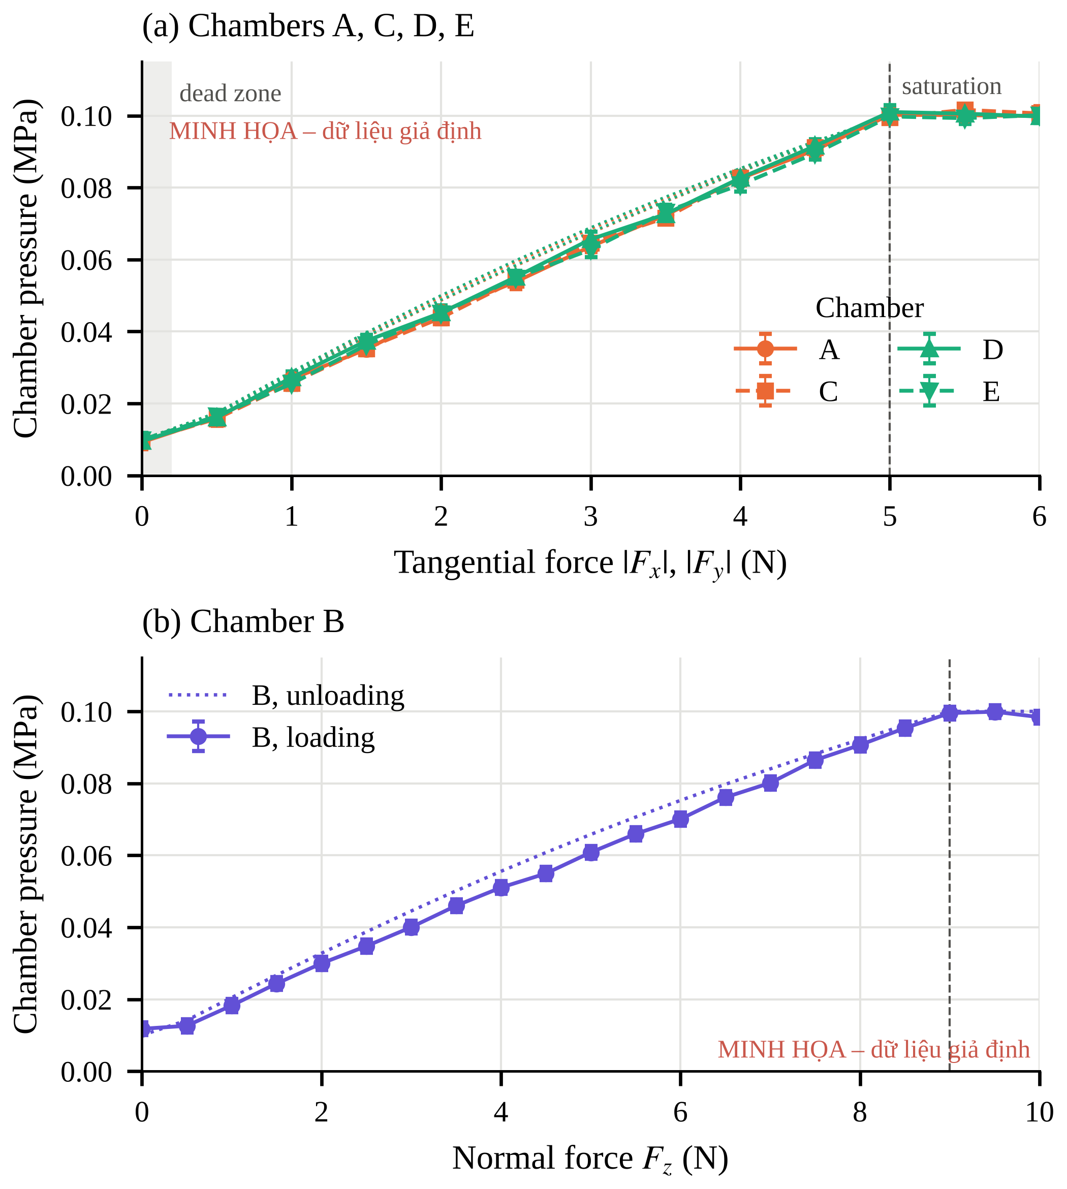
Fig. 5. Chamber pressure as a function of the sensed force (Experiment 1a). (a) Tangential chambers A, C, D, E. (b) Normal chamber B. Markers show the mean of [5] repetitions on the loading branch and error bars the standard deviation; dotted lines show the unloading branch. [Illustrative mock-up with synthetic data; replace with measured results.]
TABLE II
Static Force–Pressure Relation of Each Chamber (Experiment 1a)
Chamber | Force | a (MPa/N) | b (MPa) | R² | Hysteresis (%FS) | Crosstalk (%)
A | −F_{x} | […] | […] | […] | […] | […]
B | F_{z} | […] | […] | […] | […] | […]
C | +F_{x} | […] | […] | […] | […] | […]
D | −F_{y} | […] | […] | […] | […] | […]
E | +F_{y} | […] | […] | […] | […] | […]

B. Bandwidth
Fig. 6 shows the frequency response of the five chambers. [Describe the magnitude roll-off and phase lag; compare chambers.] The −3 dB bandwidth ranged from [x.x] Hz (chamber […]) to [x.x] Hz (chamber […]) (Table III).
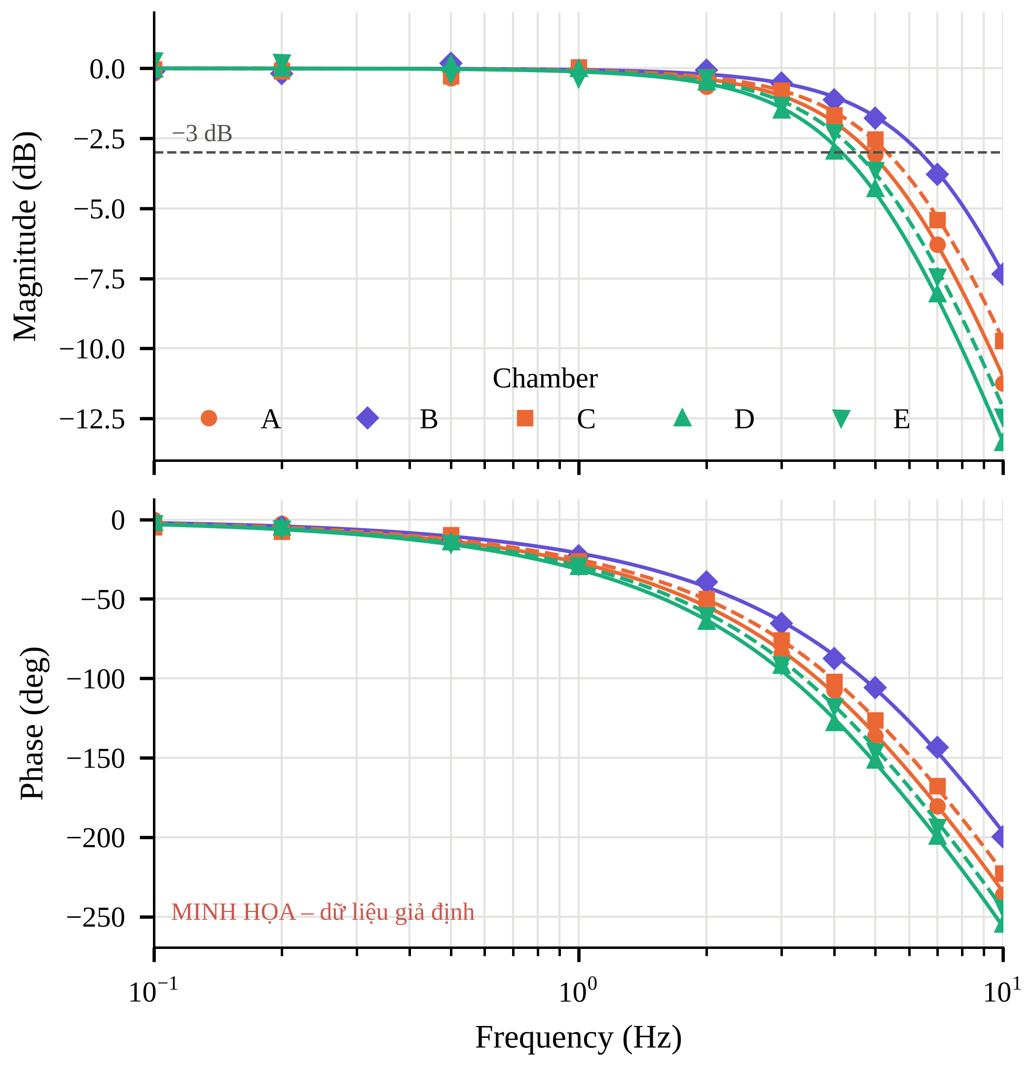
Fig. 6. Frequency response of the chamber pressure (Experiment 1b). Markers show the measured values, lines a fitted [second-order model with time delay], and the dashed line −3 dB. [Illustrative mock-up with synthetic data; replace with measured results.]
TABLE III
Bandwidth of Each Chamber (Experiment 1b)
Chamber | A | B | C | D | E
f_{c} (Hz) | […] | […] | […] | […] | […]
Phase at f_{c} (deg) | […] | […] | […] | […] | […]

C. JND of Each Chamber
Fig. 7 shows the JND of each chamber across participants, and Table IV lists the mean values. [Report the chamber effect: test statistic, p-value; which chambers differ. For chamber B, report whether k stays constant across the three reference levels.]
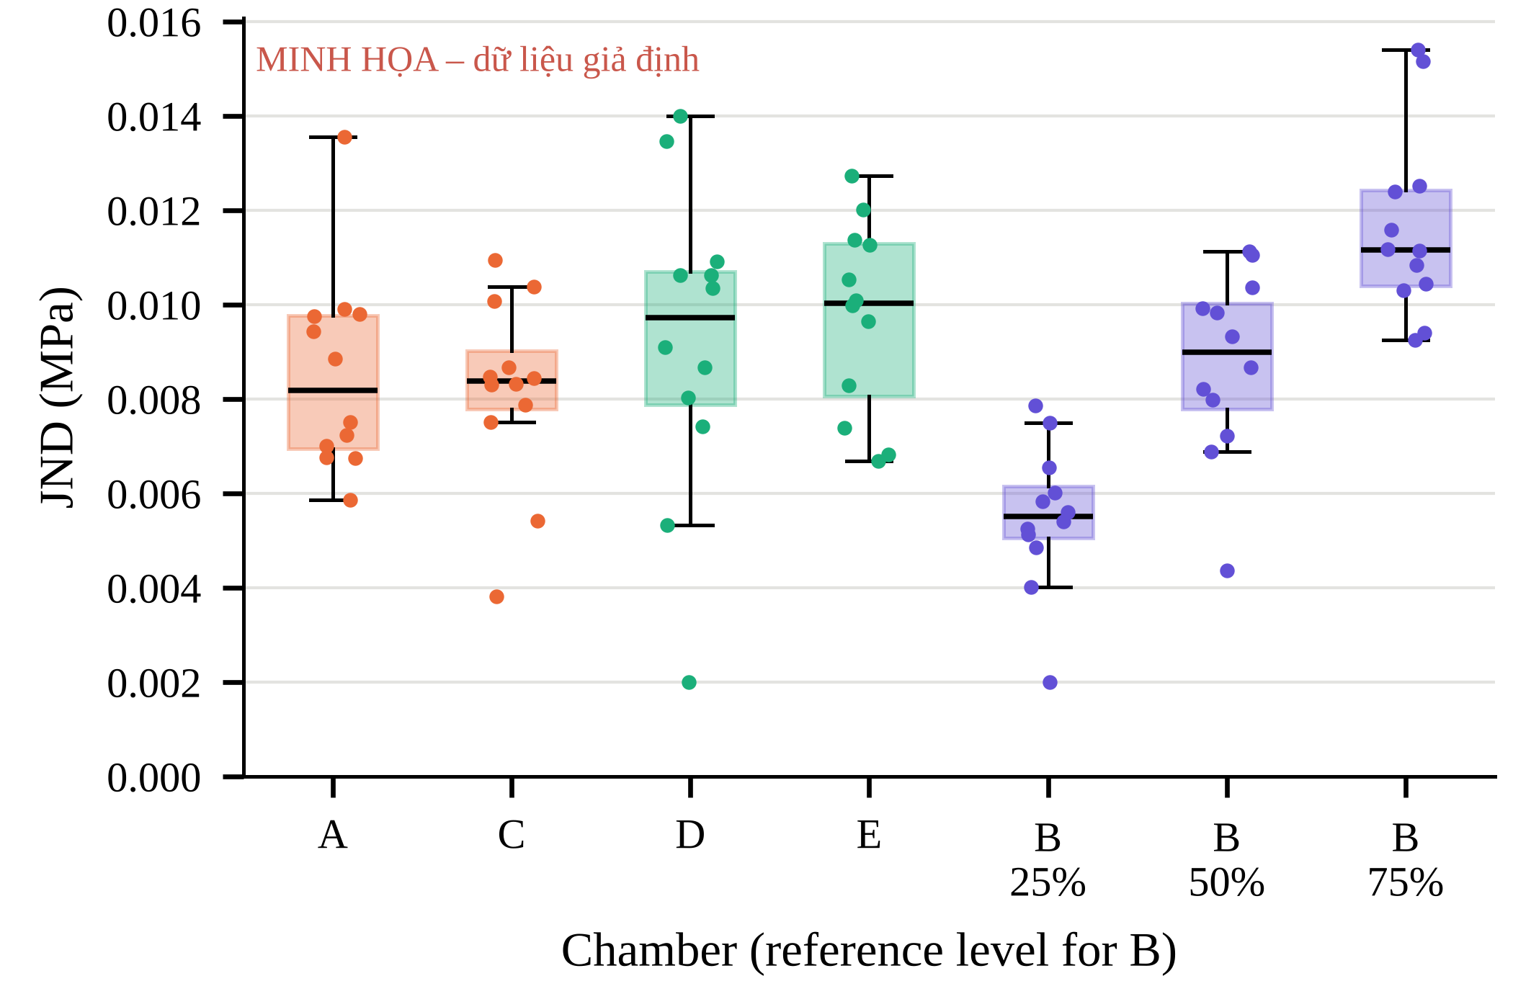
Fig. 7. JND of each chamber (Experiment 2, [N] participants). Boxes show the median and interquartile range; dots show individual participants. [Illustrative mock-up with synthetic data; replace with measured results.]
TABLE IV
JND and Weber Fraction (Mean ± SD, Experiment 2)
Chamber | P_{ref} (MPa) | JND (MPa) | k
A | […] | […] ± […] | […] ± […]
B (25%) | […] | […] ± […] | […] ± […]
B (50%) | […] | […] ± […] | […] ± […]
B (75%) | […] | […] ± […] | […] ± […]
C | […] | […] ± […] | […] ± […]
D | […] | […] ± […] | […] ± […]
E | […] | […] ± […] | […] ± […]

D. Identification of Motion Direction
Fig. 8 shows the confusion matrix pooled across participants. The overall accuracy was [xx] ± [xx]%, above the chance level of 20% ([test, p-value]). [Report the accuracy per class; the most frequent confusions (e.g., between pull and push, or between squeeze and slide); response time per class.]
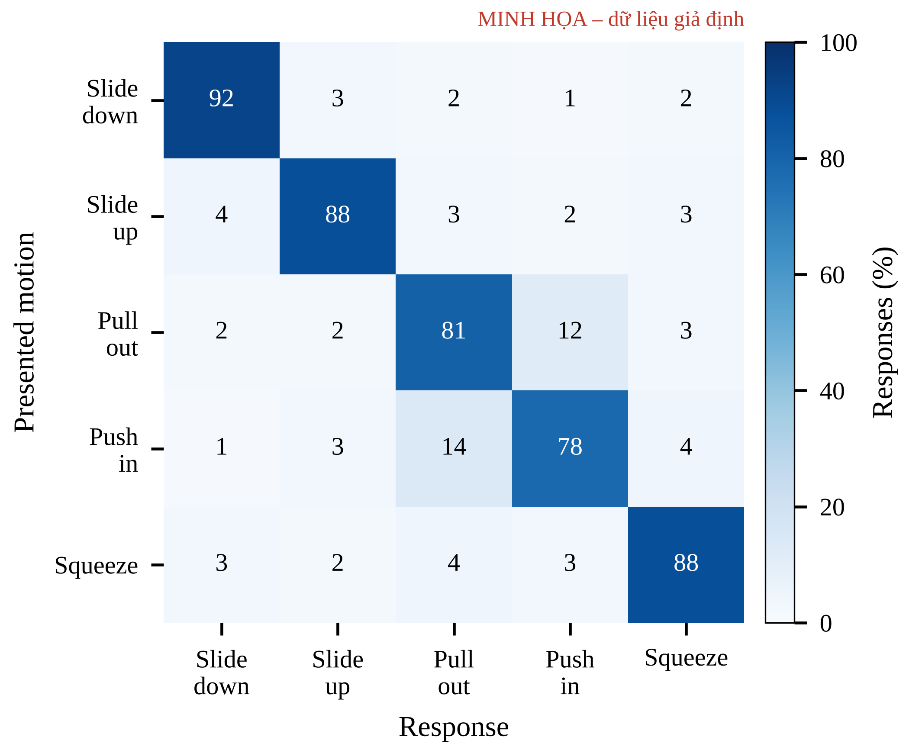
Fig. 8. Confusion matrix of motion-direction identification (Experiment 3). Rows: presented motion; columns: response. [Illustrative mock-up with synthetic data; replace with measured results.]

V. Discussion

A. Fidelity of the Tactile Channel
[Interpret Experiment 1a: whether the channel is linear over the force range of typical grasps; what the dead zone and saturation imply for light and heavy objects; effect of hysteresis and crosstalk on direction rendering.] [Interpret Experiment 1b: compare the bandwidth with the time scale of slip onset and with the approximately 4.5 Hz bandwidth reported for the two-degree-of-freedom SuP-Ring [7]; identify the dominant lag (regulator, tube, chamber volume).]

B. Perception
[Interpret Experiment 2: differences in JND between the base chambers and the side-wall chambers; relation to skin location and membrane contact; how many distinguishable pressure levels fit between P₀ and P_{max} (spacing of about 2 JND).] [Interpret Experiment 3: which directions are easy or confused and why (chamber location, crosstalk); compare with direction perception for tangential skin displacement [16] and with the earlier prototype [11].]

C. Limitations and Future Work
[Edit as needed:] The mapping uses the resultant force of one finger and does not yet render the CoP shift or the contact area. The participants were passive and did not control the gripper, so the effect of the feedback on grasping performance in closed-loop teleoperation was not tested. The end-to-end latency from the sensor to the chamber pressure was not measured in this study. The sample size of [N] participants limits the generalization of the psychophysical results. Future work will render slip-related features such as the friction utilization and test whether the display lets operators react before the object slips [8].

VI. Conclusion
This paper presented a tactile channel from an array tactile sensor on a two-finger gripper to a three-degree-of-freedom pneumatic fingertip display with five chambers. The static relation between the sensed force and the chamber pressure was linear (R² ≥ […]) with gains of […]–[…] MPa/N, and the −3 dB bandwidth was […]–[…] Hz. The JND was […] MPa on average, with a Weber fraction of […]. Passive wearers identified five directions of object motion with […]% accuracy. [One sentence on the next step.]

Acknowledgment
[Acknowledge people and facilities; funding goes in the first-page footnote for IEEE.]

References
[1] R. S. Johansson and J. R. Flanagan, “Coding and use of tactile signals from the fingertips in object manipulation tasks,” Nat. Rev. Neurosci., vol. 10, no. 5, pp. 345–359, 2009, doi: 10.1038/nrn2621.
[2] R. S. Dahiya, G. Metta, M. Valle, and G. Sandini, “Tactile sensing—From humans to humanoids,” IEEE Trans. Robot., vol. 26, no. 1, pp. 1–20, Feb. 2010, doi: 10.1109/TRO.2009.2033627.
[3] W. Yuan, S. Dong, and E. H. Adelson, “GelSight: High-resolution robot tactile sensors for estimating geometry and force,” Sensors, vol. 17, no. 12, Art. no. 2762, 2017, doi: 10.3390/s17122762.
[4] W. Chen, H. Khamis, I. Birznieks, N. F. Lepora, and S. J. Redmond, “Tactile sensors for friction estimation and incipient slip detection—Toward dexterous robotic manipulation: A review,” IEEE Sensors J., vol. 18, no. 22, pp. 9049–9064, Nov. 2018, doi: 10.1109/JSEN.2018.2868340.
[5] C. Pacchierotti, S. Sinclair, M. Solazzi, A. Frisoli, V. Hayward, and D. Prattichizzo, “Wearable haptic systems for the fingertip and the hand: Taxonomy, review, and perspectives,” IEEE Trans. Haptics, vol. 10, no. 4, pp. 580–600, Oct.–Dec. 2017, doi: 10.1109/TOH.2017.2689006.
[6] H. H. Ly, Y. Tanaka, and M. Fujiwara, “SuP-Ring: A pneumatic tactile display with substitutional representation of contact force components using normal indentation,” Int. J. Med. Robot. Comput. Assist. Surg., vol. 17, no. 6, Art. no. e2325, 2021, doi: 10.1002/rcs.2325.
[7] H. H. Ly, Y. Tanaka, and M. Fujiwara, “Tumor depth and size perception using a pneumatic tactile display in laparoscopic surgery,” IEEE Access, vol. 9, pp. 167795–167811, 2021, doi: 10.1109/ACCESS.2021.3135698.
[8] J. M. Walker, A. A. Blank, P. A. Shewokis, and M. K. O’Malley, “Tactile feedback of object slip facilitates virtual object manipulation,” IEEE Trans. Haptics, vol. 8, no. 4, pp. 454–466, Oct.–Dec. 2015, doi: 10.1109/TOH.2015.2420096.
[9] N. Becker [et al., full author list], “Integrating and evaluating visuo-tactile sensing with haptic feedback for teleoperated robot manipulation,” 2024, arXiv:2404.19585.
[10] N.-D. Tran, H.-H. Ly, X.-T. Nguyen, T.-T. Mac, A. Nguyen, and T. D. Ta, “Hybrid gripper with passive pneumatic soft joints for grasping deformable thin objects,” 2024, arXiv:2410.05789.
[11] X. L. Đinh and H. L. Hồ, “[thesis title],” B.Eng. thesis, [Hanoi Univ. Sci. Technol.], Hanoi, Vietnam, 2026 (in Vietnamese).
[12] [PaXini Technology], “[S2015-Elite tactile sensor datasheet],” [year]. [Online]. Available: [URL]
[13] SMC Corporation, “[Electro-pneumatic regulator ITV1000/2000/3000 series],” [catalog no., year]. [Online]. Available: [URL]
[14] L. A. Jones and H. Z. Tan, “Application of psychophysical techniques to haptic research,” IEEE Trans. Haptics, vol. 6, no. 3, pp. 268–284, Jul.–Sep. 2013.
[15] H. Levitt, “Transformed up-down methods in psychoacoustics,” J. Acoust. Soc. Am., vol. 49, no. 2B, pp. 467–477, 1971, doi: 10.1121/1.1912375.
[16] B. T. Gleeson, S. K. Horschel, and W. R. Provancher, “Perception of direction for applied tangential skin displacement: Effects of speed, displacement, and repetition,” IEEE Trans. Haptics, vol. 3, no. 3, pp. 177–188, Jul.–Sep. 2010, doi: 10.1109/TOH.2010.20.

